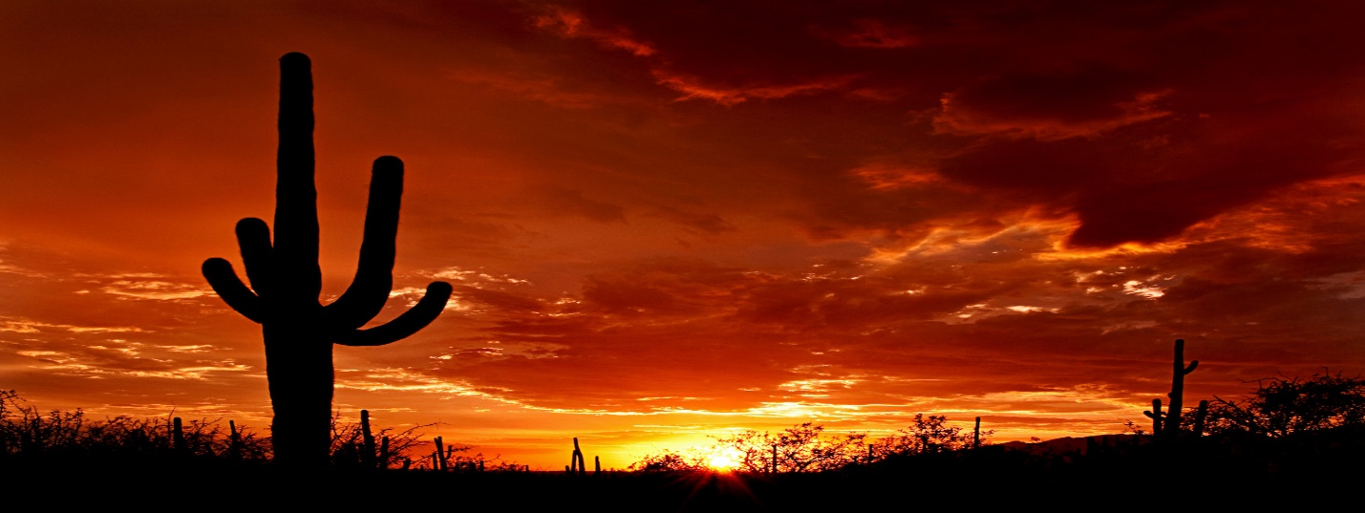

**Table of Contents:**

* **North American Mythology.**
* **The Original Man of Steel.**
* **Way Out West.**
* **Stronger than Most Men****.**
* **Tallest Tale of them All.**

**North American Mythology**

**By Matthew Beaver**

**American Mythos**

American Tall Tales

America has a unique Mythology as diverse and as fantastic as the rest of the worlds. This American Mythology known as Tall Tales, still lives despite decades since their creation by being retold in many ways. America’s Tall Tales share characteristics with the rest of the world’s Mythologies:

1. Used to explain the world around them and pass the time telling the tales.
2. The protagonists are superhuman in some form and the obstacles are exaggerated.
3. Fill the listener with a strong emotion from wonderment, inspiration, terror, and sorrow.

**The Original Man of Steel.**

His full name was John Henry, and he was what railroad workers called a “steel driving man”. John Henry’s tale begins as a child born into slavery. From birth John Henry was required to do the work of a full-grown man which made him strong. When the American Civil War ended; John Henry got a job breaking up rocks and making tunnels for railroads. Joh Henry did this by using a hammer and drill bit to shatter the stone. John Henry worked faster and harder than any worker. With his immense physical strength and his kind heart earned the admiration of his fellow workers. One day however, an inventor introduced a steam powered drill that could break rock faster than the entire railroad crew. With the threat of losing their jobs, John Henry challenged the steam drill to a race of tunneling through a mountain. The race artistically depicted in figure 1, was a hard one for John Henry but by the end of it he broke through the mountain first. John Henry despite winning passed away due to the stress the effort of the race put on his heart. Surprisingly enough, historians believe a real-life John Henry like figure could have existed. [Here is the link on the real John.](https://www.nytimes.com/2006/10/18/books/18grim.html)

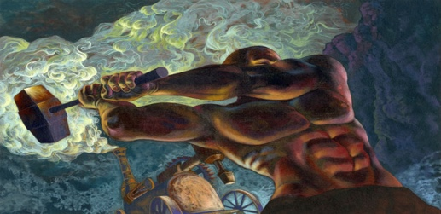

***John’s Race*** Fig. 1. John Henry’s famous race against the inventor’s steam drill.

.

**Way out West.**

There is no one who could claim to have tamed “the wild west” as much as Texas Tall Tale, Pecos Bill. His tale, popular with Cowboys, begins when Pecos Bill and his brother were born in Texas around 1830. One day Bills family decided to move while he was still a baby. On the way to his destination Pecos Bill fell off their family’s wagon near the Pecos river, hence his name. There he was found and raised by coyotes until his brother later discovered him and brought him back to civilization. From their Pecos Bill got a job as a cowboy and during that time had many fantastic feats and tales like:

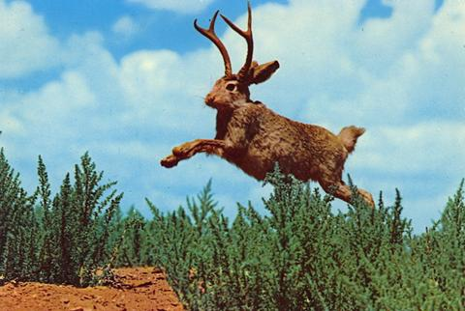

One Jackalope origin states in 1932 Douglas Herrick, a hunter, threw a rabbit pelt into a pile of deer antlers which inspired him to taxidermy the first Jackalope.

***Weird West***

* Pecos Bill used a rattle snake, named Shake, as a lasso.
* Was the only one who could safely ride his horse Widow Maker.
* Dynamite was his favorite food.
* Alone dug the Rio Grande.
* Lassoed and rode a tornado like a horse as he prepares to do in Fig. 2.
* Sometimes rode mountain lions instead of Widow Maker.
* Fought and apprehended many criminals.
* Shot all the stars out of the Texas sky except for one, which became the “Lone Star of Texas”.

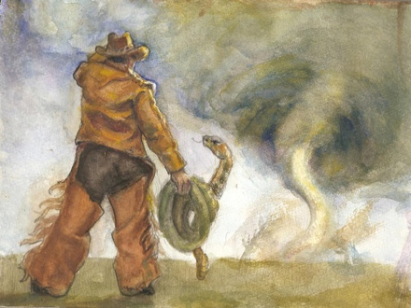

***Taming the West*** Fig. 2. Pecos Bill and Shake prepare to lasso a tornado.

**Stronger than Most Men.**

Down near the Mississippi, you will find a female Tall Tale. This Tall Tale was victorious over all challenges both physical and societal in the south. Her name is Annie Christmas. Annie Christmas, was a seven-foot-tall, African-American woman who captained her own keel boat, (you can get more information on keel boats with this [link](https://www.encyclopedia.com/social-sciences-and-law/political-science-and-government/military-affairs-nonnaval/keelboat)) named “Big River’s Daughter”, could carry three heavy barrels with one arm, and never married but had twelve sons. If there is one iconic item of Annie Christmas’s, it’s that of her pearl necklace. Each pearl of Annie Christmas’s necklace represented a man who openly challenged her that she defeated. They say the pearl necklace reached thirty feet in length of pearls.

**“Can’t tame Mam any more than you can tame that Mississippi...”- one of Annie’s twelve Sons**

One of Annie’s most famous tales began while she was on a steam boat, where she tied the end of her keel boat to. Despite Annie’s knowledge of the Mississippi River, and the stormy weather the Captain would not listen to her warnings. The captain ended up sinking his steam boat but Annie Christmas was able to get every passenger on her keel boat. Despite the weight of many people which would make moving the keel boat harder, and the stormy weather; Annie Christmas navigated everyone to safety without breaking a sweat. **Tallest Tale of them All.**

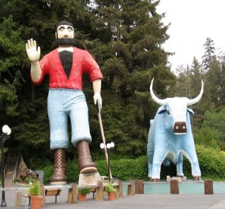

***Statuesque*** Fig. 4. A Statue depiction of Paul Bunyan and Babe the blue ox.

From the southern Mississippi River to the Pines of the Northwest there lies a literal “tall” tale by the name of Paul Bunyan. Lumberjacks from all over the Northwestern United States shared his tales orally in bunkhouses to pass time. Five giant storks delivered the one-hundred-pound baby Paul Bunyan to his parents in Maine. As a young boy, he learned the lumberjack trade from his father and excelled at it with his superhuman strength and size. Paul Bunyan discovered his iconic companion, the blue ox Babe, traveling through a blue colored snow storm. Once found Babe continued to grow day after day to Paul Bunyan’s size. From Maine Paul Bunyan headed west. Paul Bunyan and Babe are credited in his tales for creating, the Grand Canyon by dragging his ax behind him. Paul Bunyan has been a topic of many statues such as figure 4.

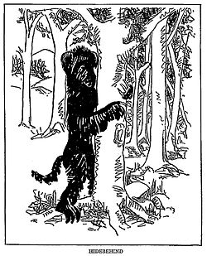

Lumberjacks had many fantastical animals they called “fearsome critters” but none was as frightening as the “HideBehind”. This was the folkloric explanation for lumberjack disappearances. The “HideBehind” would stay in a lumberjack’s blind spot until it could eat him.

***Unforeseen Danger of the Pines.***

I decided upon American Tall Tales for my newsletter because I see them as an essential part of storytelling history that reflect upon the time of their creation. I wanted to recreate within the newsletter how the stories grabbed their listeners with wonderment and inspiration when they were first told in America.

To start the format, I chose an American desert’s sunset for the cover image. This is because a desert sunset with cacti reflects Americas history of the legendary “Wild West”. This image is clearly identifiable with America, and the feeling its beauty gives. This uniquely American sunset I felt captured the wonderment of heading out into the western frontier while still having a feeling of warm optimism. Next, I wanted the colors to reflect the cover image I used in the title to maintain the feelings it created. That is why I selected soft orange to keep the newsletter warm with some wonderment. Then added a darker band in the middle of the orange to prevent it from being one block of monotonous color. I went through many introductions to the newsletter until I decided upon numbered bullets to present iconic characteristics of the American Tall tale. I chose a two-column format for the newsletter because I felt helped readability and did not feel as overwhelming or claustrophobic than a three-column newsletter. I decided the title “American Mythos” because it’s short, captures the attention and sums up my feelings of American Tall Tales. The reason I chose the font “Castellar” for the title “American Mythos” because it looked both western but architecturally Greek with its own rich mythological history. To introduce the larger than life topics I chose word art in times new roman to represent their overall boldness, strength and larger than life attitude of each Tall Tale. To tie the entirety of the newsletter font together I followed some advice and made the font white. Making the font white just made the whole piece brighter, a little more interesting than regular dark text, and enhanced legibility. The links I found are basically information on real-life things that tie to the Tall Tale they are in. Not everyone recognizes what a keel boat is but to get an idea of Annie’s physical strength it helps to know. This is why I included a link about keel boats to enhance reader information and understanding. Then with John Henry, while researching found a webpage discussing he might have been based on a real-life person. With alignment, I chose left align because it read easier. I tried “justify” but it left inconsistent spacing between words

The figures I chose were Pecos Bill, John Henry, Paul Bunyan and female Tall Tale Annie Christmas. I added Annie Christmas to add diversity to the male dominated world of Tall tales. I technically summarized all their tales as much as I could in this newsletter to take part in the tradition of recounting their stories so many have done before. Pecos Bill, though, did not have one big tale or overarching characteristic like Annie’s pearl necklace he merely had many isolated feats and events that showcase his strength. Because of Pecos Bills many smaller events I decided to list these feats in bullet point to give the audience an idea of his adventures and character. I didn’t just want to discuss folkloric characters but of creatures said to be in the folkloric character’s previously unknown and thought to be mythical landscapes. Thus, the small text boxes I created about the American Wests iconic Jackalope with its possible origin and the North-Wests less known lumber jack boogeyman the “Hidebehind.” With Graphics, I provided separate pictures that represents Pecos Bill and John Henry doing something iconic in their tales that show their strength of character, power, and stoicism Henry. For Paul Bunyan, I gave an example of one of many statues of Paul Bunyan and Babe the blue ox to show how famous he is. Annie Christmas however I could not discover art that I felt captured her character sadly. However, I did find a quote that summed up her character strongly by one of her sons in one tale. I took the quote and added New Orleans Colors to it as to represent where Annie came from.